Lab 9 - Profiling
Kevin Antoun
This lab uses cProfile, line_profiler, memory_profiler and coverage.py to examine a Python script. The original code uses loops to calculate sums of squares. In the optimized version, the loops are replaced with the sum-of-squares formula, while the two-second sleep is kept unchanged.

1. cProfile

Before optimization
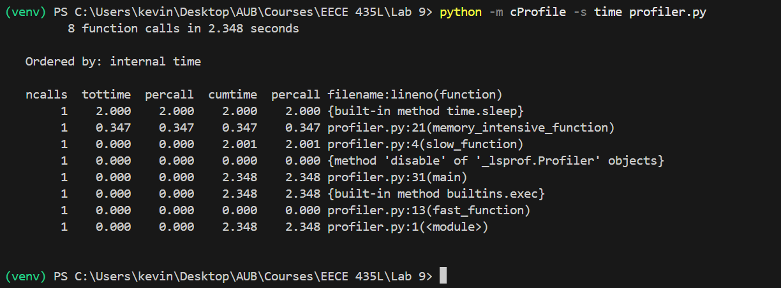
The original script took 2.348 seconds in this run. The two-second sleep took most of the time, while memory_intensive_function() used about 0.347 seconds for its 10 million iterations. The fast function was too short to show a meaningful time at this precision.

After optimization
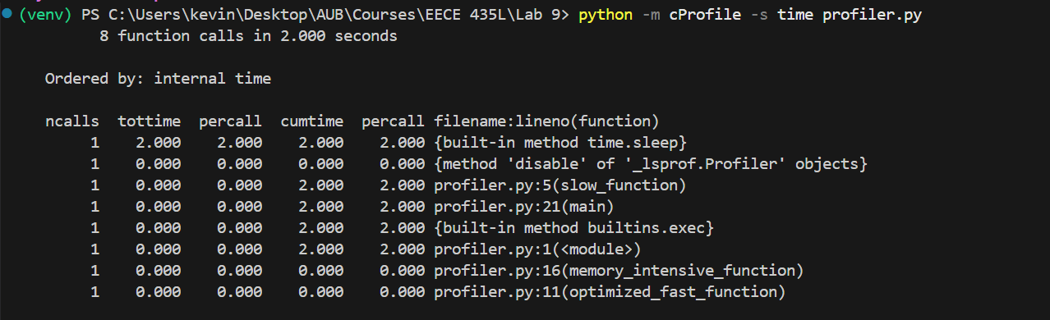
After replacing the loops with the formula, total time decreased to about 2.000 seconds. The calculations now register as 0.000 seconds when rounded to three decimal places. The two-second sleep is still the main bottleneck, so the total program cannot become much faster unless that delay is removed.

2. Line profiling

Before optimization
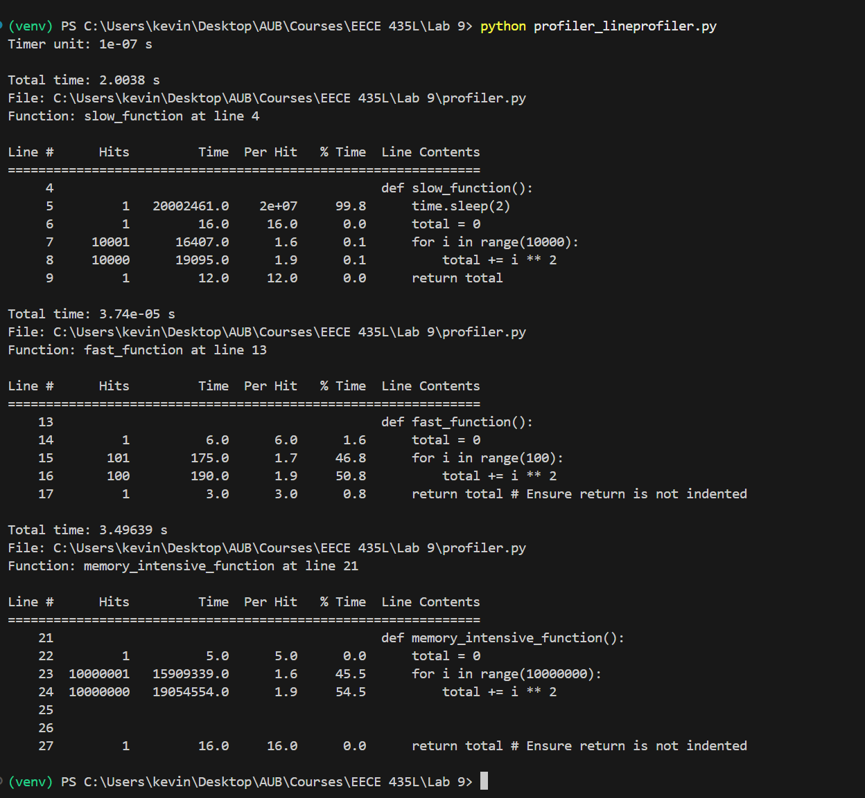
The line-by-line results show that slow_function() spent almost all its time in time.sleep(2). The large loop in memory_intensive_function() was also expensive: its 10 million additions and loop iterations account for nearly all the recorded time in that function. The line profiler itself adds overhead, so these times are different from the cProfile results.

After optimization
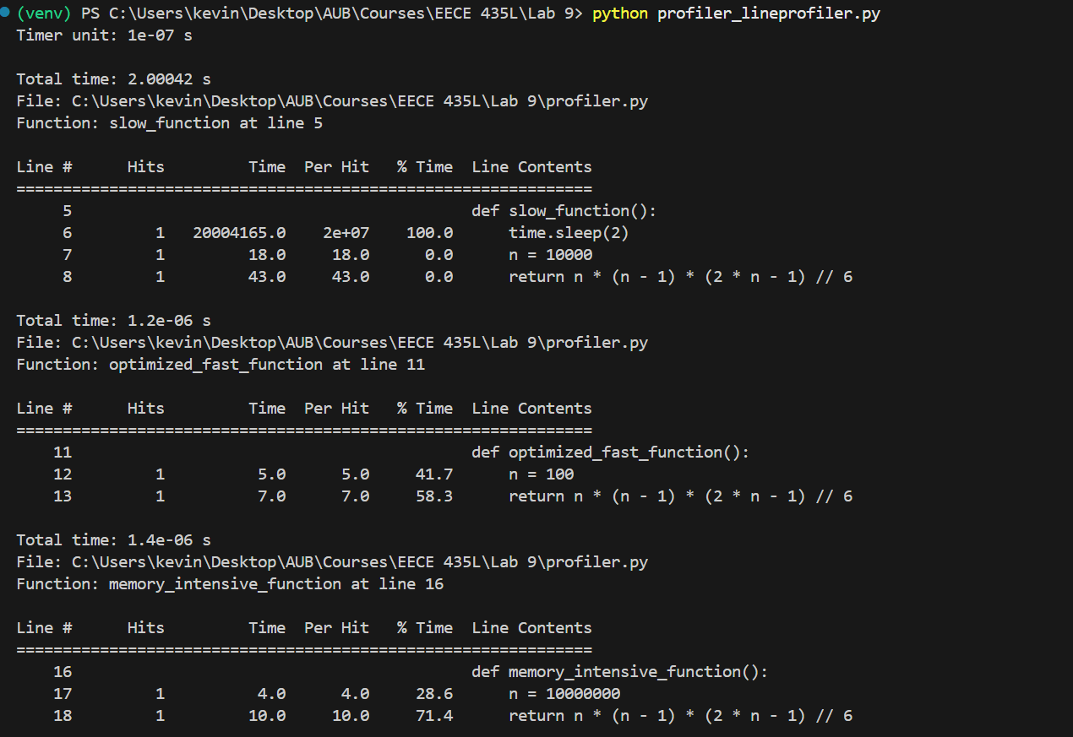
In the optimized version, each sum of squares is calculated directly. The profiler now records just one execution of the formula instead of thousands or millions of loop operations. The memory-intensive calculation is reduced to approximately 1.4 microseconds in this line-profiler run, while slow_function() remains close to two seconds because of the sleep.

3. Memory profiling

Before optimization
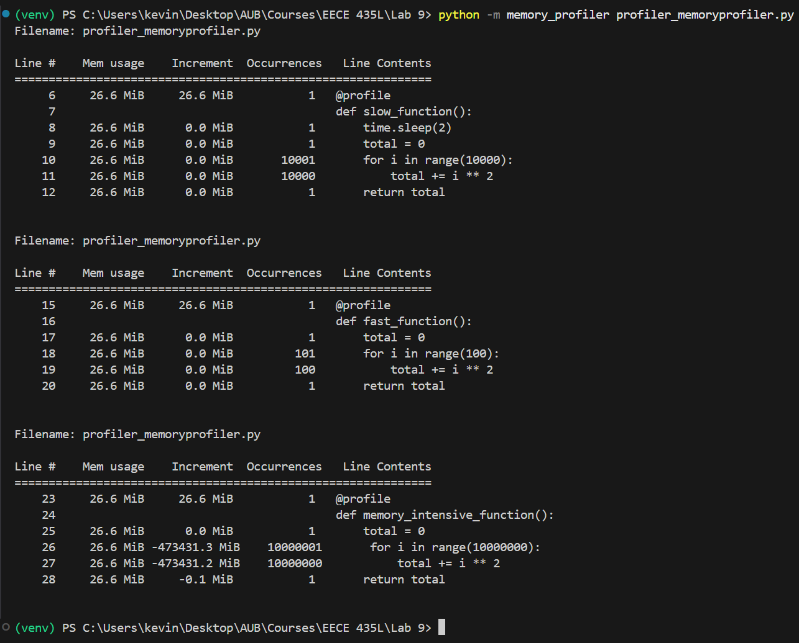
Memory usage stayed near 26.6 MiB across the original functions. Although memory_intensive_function() performs many calculations, it only keeps a running total and does not build a large list. The very large negative increments shown for the loop are artifacts of how the profiler sums repeated line measurements; they do not mean that hundreds of thousands of MiB were freed.

After optimization
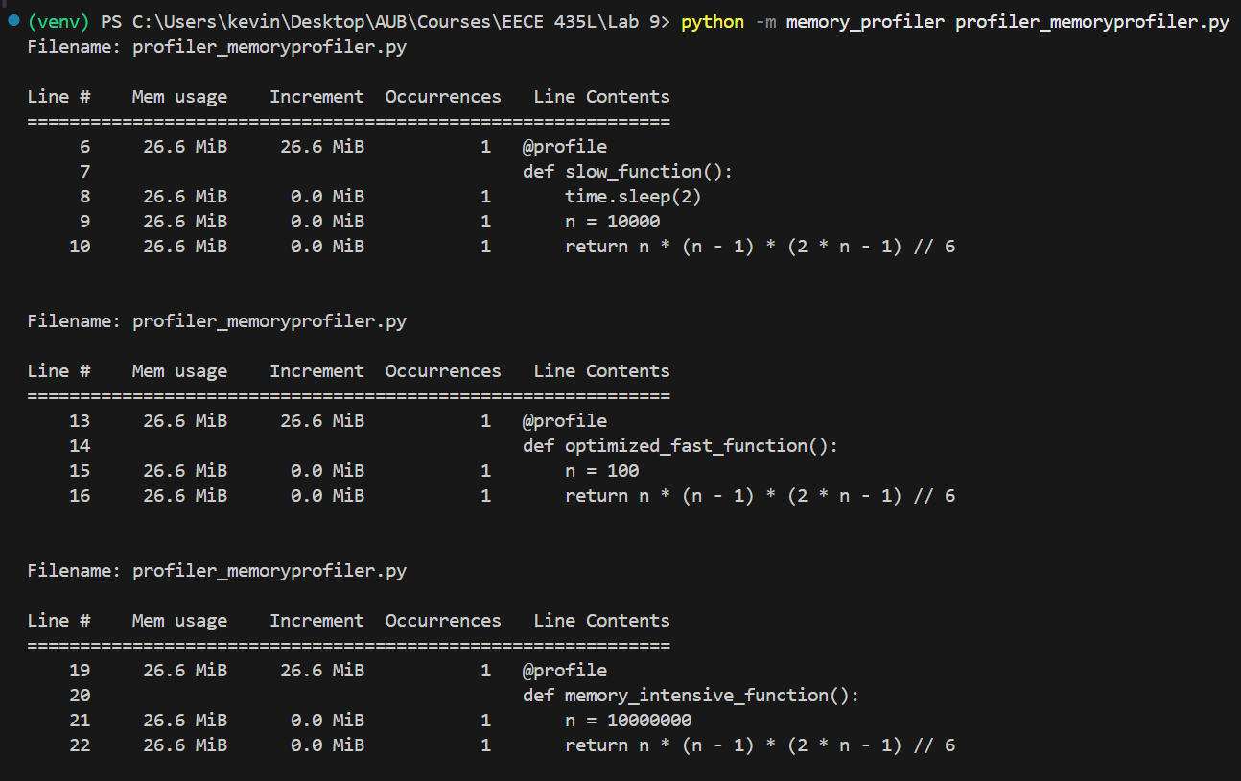
Memory usage was again around 26.6 MiB, with no measurable increase on the calculation lines. This means the main benefit of the optimization is reduced CPU work and execution time, not a large reduction in memory use. The new version also removes the repeated-loop measurements that made the original report difficult to interpret.

4. Unit tests

Before optimization
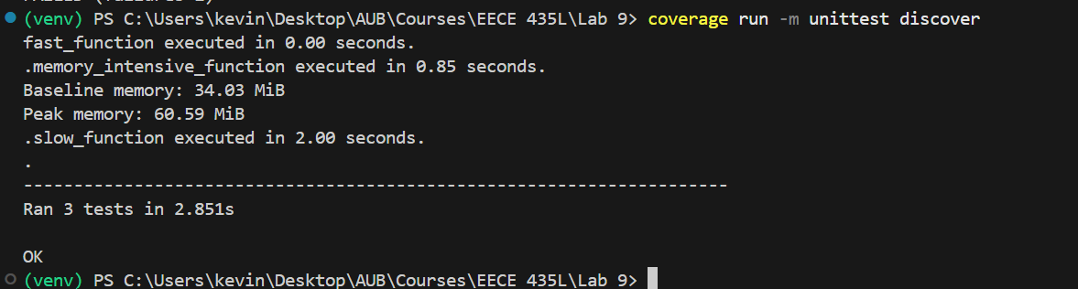
All three tests passed before optimization. The test run took 2.851 seconds, and the memory-intensive function was reported as taking about 0.85 seconds in this test execution. The two-second delay in slow_function() was also confirmed.

After optimization
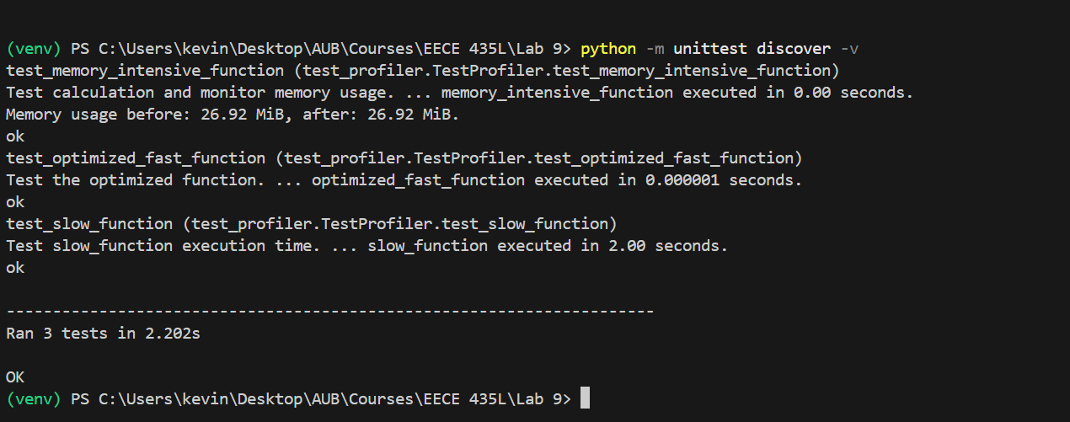
All three tests also passed after optimization, with the test suite completing in 2.202 seconds. The optimized fast and memory-intensive calculations returned their expected results and finished almost immediately. The before and after test suites and measurement methods are not identical, so the dedicated profiling results are better evidence of speed changes.

5. Code coverage

Before optimization
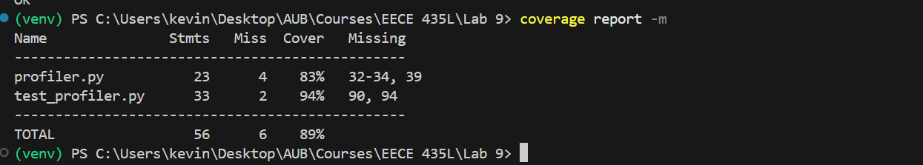
Coverage was 83% for profiler.py, 94% for test_profiler.py and 89% overall. The tests executed all three calculation functions. The missing lines in profiler.py (32-34 and 39) are from main() and the direct script entry point, which are not run when the tests import the functions individually.

HTML coverage report
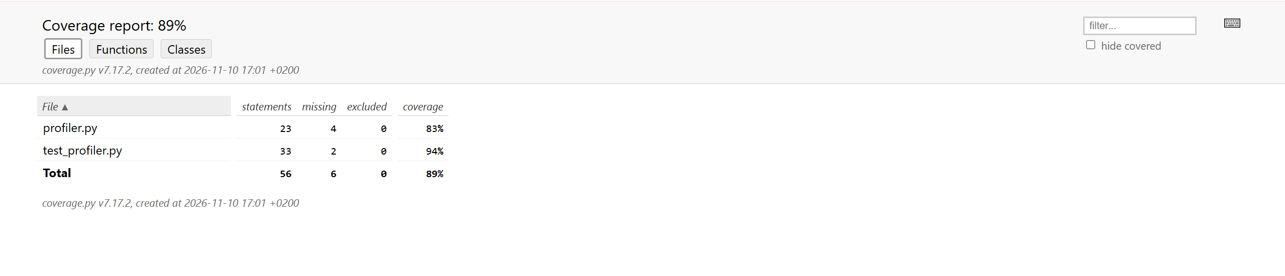
The HTML view shows the same 89% overall coverage and can be used to inspect which specific statements were missed.

After optimization
No after-optimization coverage screenshot was supplied, so the updated percentage cannot be verified. An updated coverage report and htmlcov/index.html are still needed for the final submission.

6. Optimization and comparison
The original code calculated sums of squares with loops of 100, 10,000 and 10,000,000 iterations. The optimized version uses n * (n - 1) * (2 * n - 1) // 6. This gives the same integer results without iterating. The two-second sleep was left in place to keep the original behavior of slow_function().
Measurement | Before | After
cProfile total runtime | 2.348 s | 2.000 s
cProfile: large calculation | 0.347 s | 0.000 s (rounded)
Fast function (timeit) | 2.65 us | 60.1 ns
memory_profiler usage | ~26.6 MiB | ~26.6 MiB
Unit tests | 3 passed; 2.851 s | 3 passed; 2.202 s
Coverage (overall) | 89% | Not provided
A separate timeit measurement of the fast calculation was 2.65 microseconds per call before optimization and 60.1 nanoseconds after optimization. That is approximately 44.1 times faster, or a 97.73% reduction in execution time. The cProfile results show a smaller improvement in the full script because time.sleep(2) still determines most of its runtime.
Overall, replacing the loops with the formula made the calculations much faster without changing their outputs. The observed memory use remained roughly constant, since the original loops already used very little extra storage. The tests passed before and after the changes; an updated coverage report is still needed to complete the coverage comparison.

